***Searching for the Liquid Crystal sedimentation in Polarized Optical Microscope photos***

Szymon Baczyński   
KD-158

1. Project subject

During my research on my PhD thesis "Optofluidic systems for sensing applications", where I fill channels made in the PDMS polymer with various types of liquid crystals. These include the nematics E7, 5CB and 6CHBT. Some kind of sediment was formed during the work with E7. I have carried out many trials that resulted in the sedimentation of the liquid crystal. Due to the long process of sediment formation, one of the ideas for observation and reporting was to create a laboratory stand to collect data over time. In the meantime, many samples were checked, thanks to which I collected a database of several hundred photos. All photos are taken with the Polarized Optical Microscope - a microscope that uses crossed polarizers.

The purpose of this project is an initial review of image recognition models and checking the available tools. Due to little experience in working with image recognition tools and models, preliminary research in this field will be presented. The results and ideas for improving the system will be presented at the end.

1. Input Data

The input data used for training is a collection of 53 photos from different stages of the research. The set includes photos taken with the Keyence VHX5000 microscope. The resolution of a single photo is 1600x1200 pixels, but photos were also taken using the Stitching function, thanks to which the images have a higher resolution. Before marking the appropriate fragments, all photos were scaled to a resolution of 1600x1200 pixels. Pictures were taken with light passing through crossed polarizers. The areas where there is no Liquid Crystal are completely black (isotropic medium). Interesting parts of the photos where liquid crystal sedimentation occurs are gray and have a heterogeneous texture. In addition to photos with channels where we observe a destructive phenomenon, there are also several photos of Liquid Crystal droplets on the PDMS. In this case, the different stages of sedimentation formation can be seen very clearly. Below are some sample photos to showcase the variety of cases.

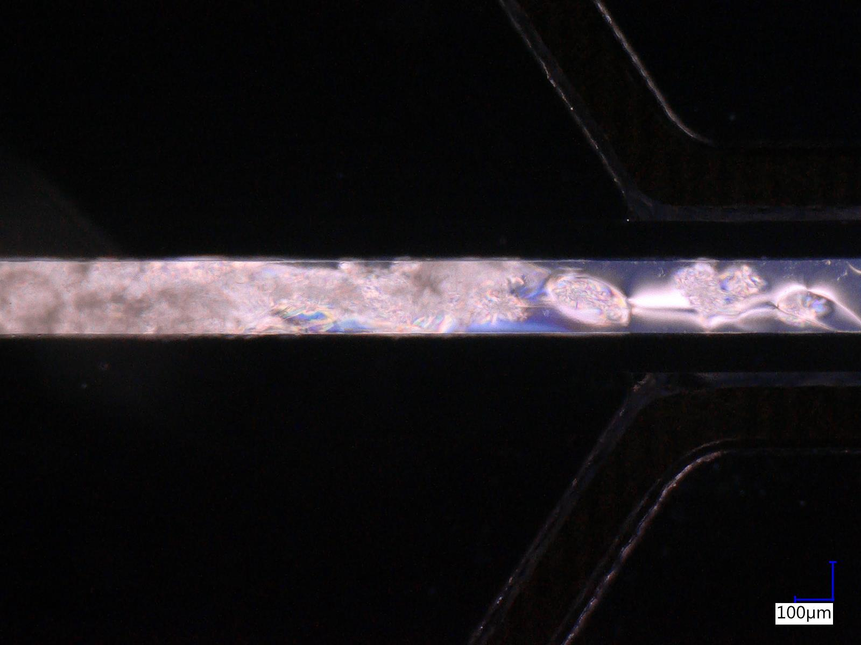 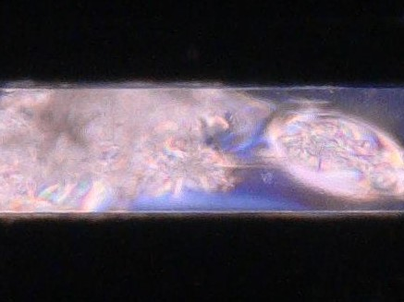  
*Microchannel in PDMS with Liquid Crystal - day 3 (after filling with LC).   
On the right, magnification of an area with progressive sedimentation.*

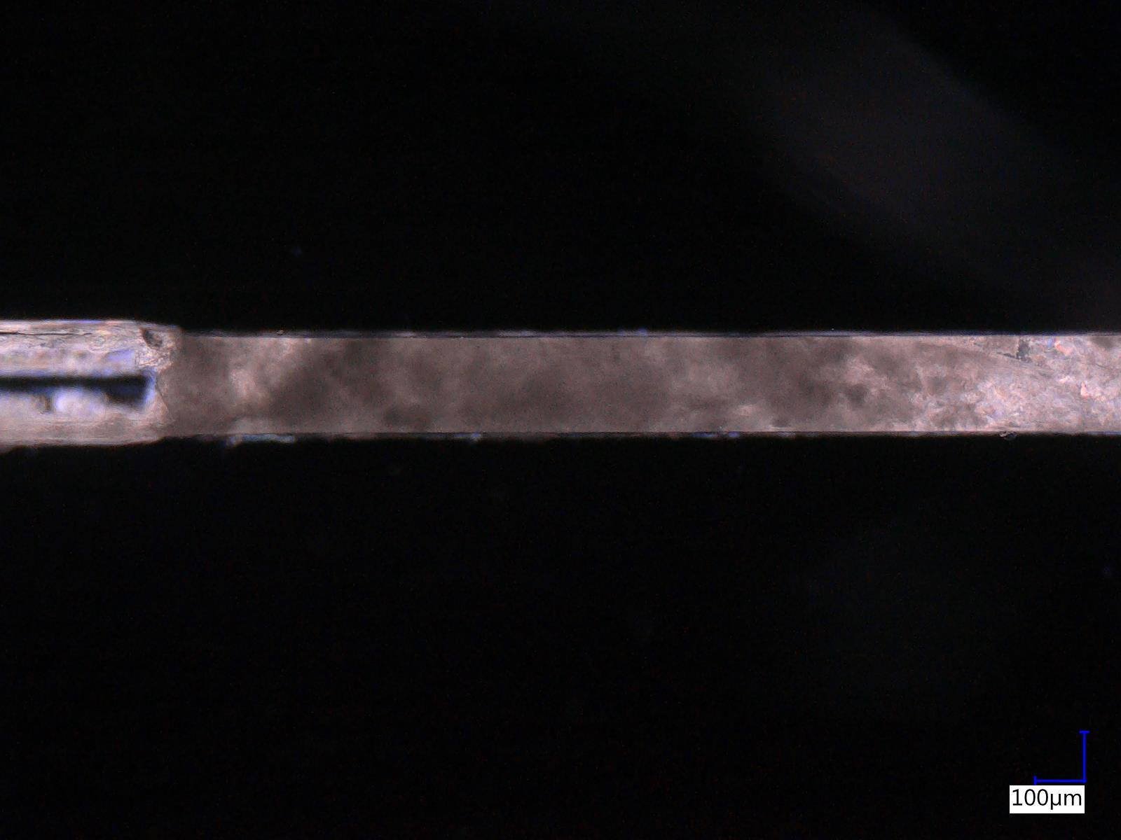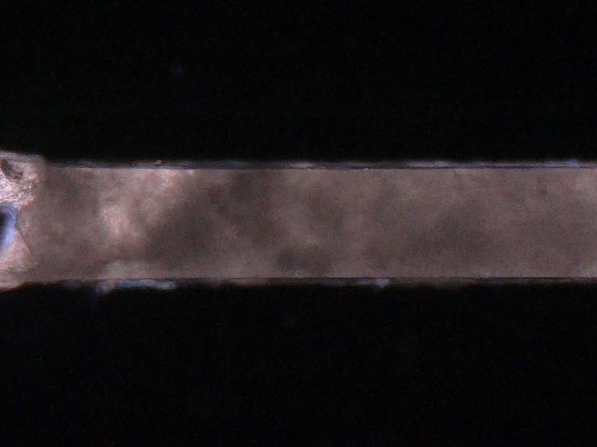  
*Microchannel in PDMS with Liquid Crystal - day 3 (after filling with LC).   
On the right, a magnification of an exemplary area of interest.*

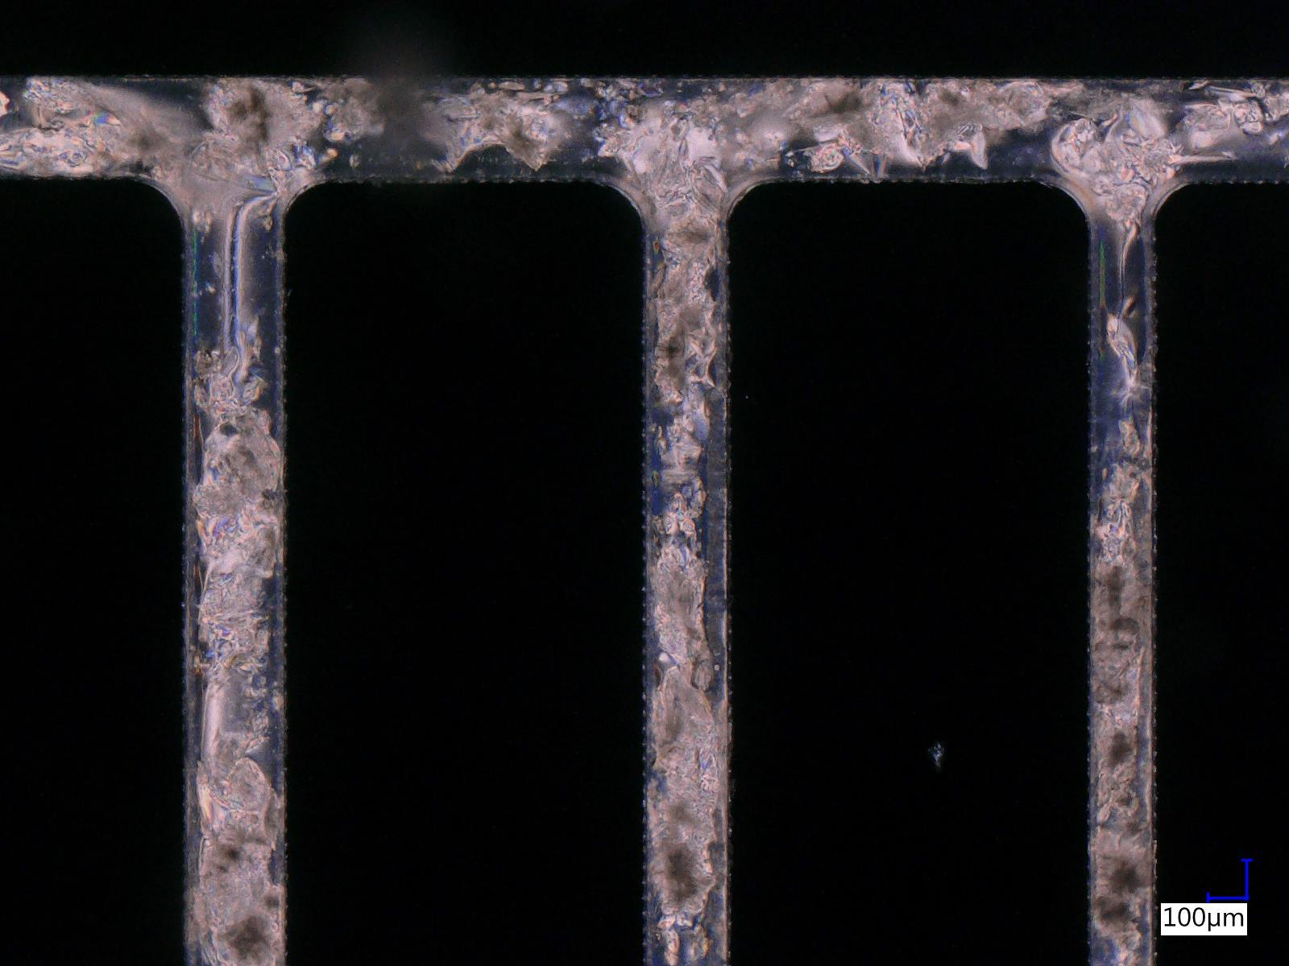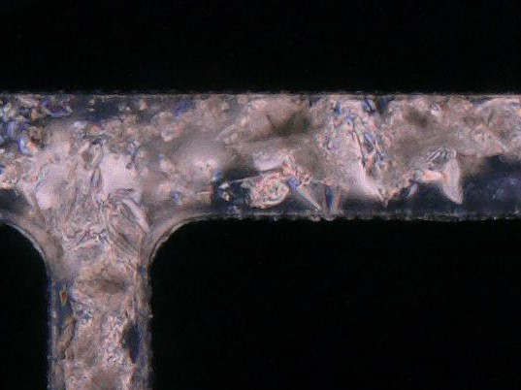  
*Microchannel in PDMS with Liquid Crystal - day 4 (after filling with LC).   
On the right, a magnification of an exemplary area of interest.*

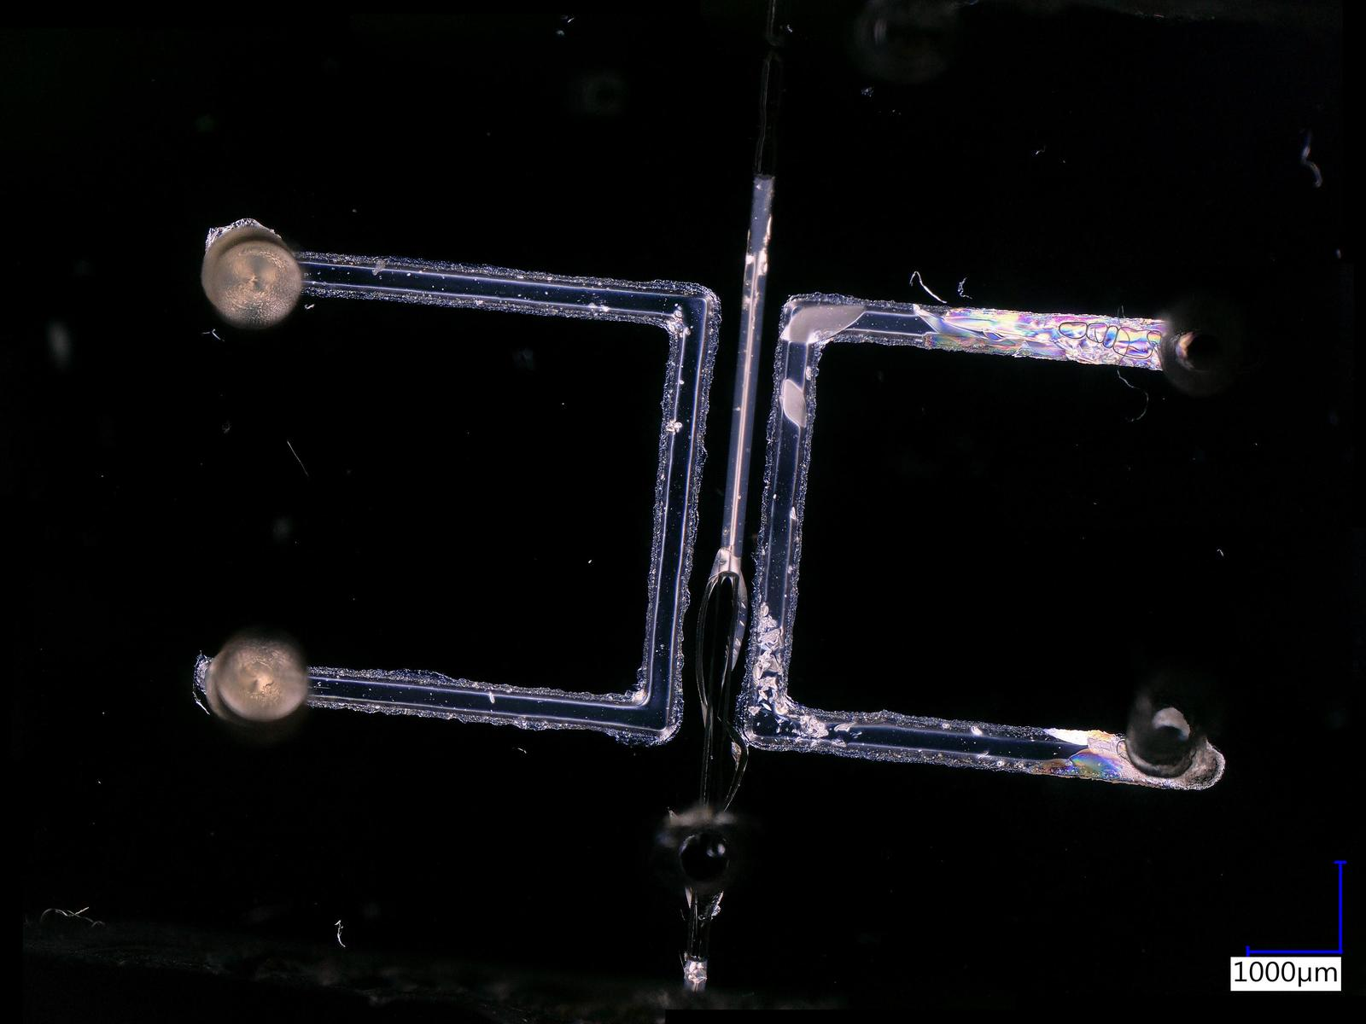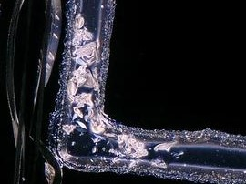  
*Microchannel in PDMS with Liquid Crystal - day 4 (after filling with LC).   
On the right, a magnification of an exemplary area of interest.*

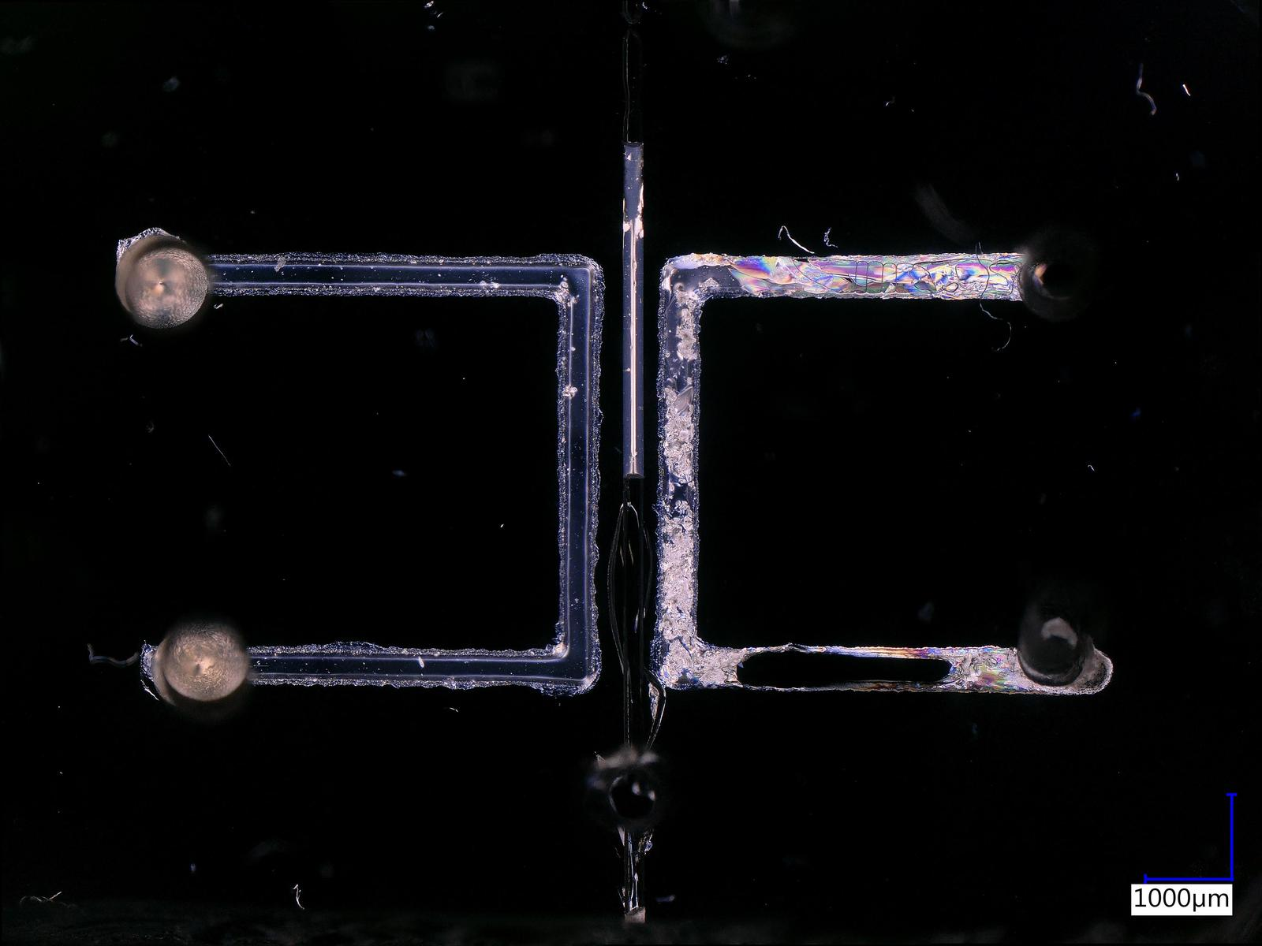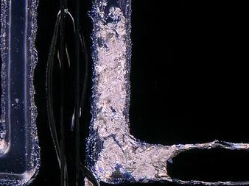  
*Microchannel in PDMS with Liquid Crystal - day 7 (after filling with LC).   
On the right, a magnification of an exemplary area of interest.*

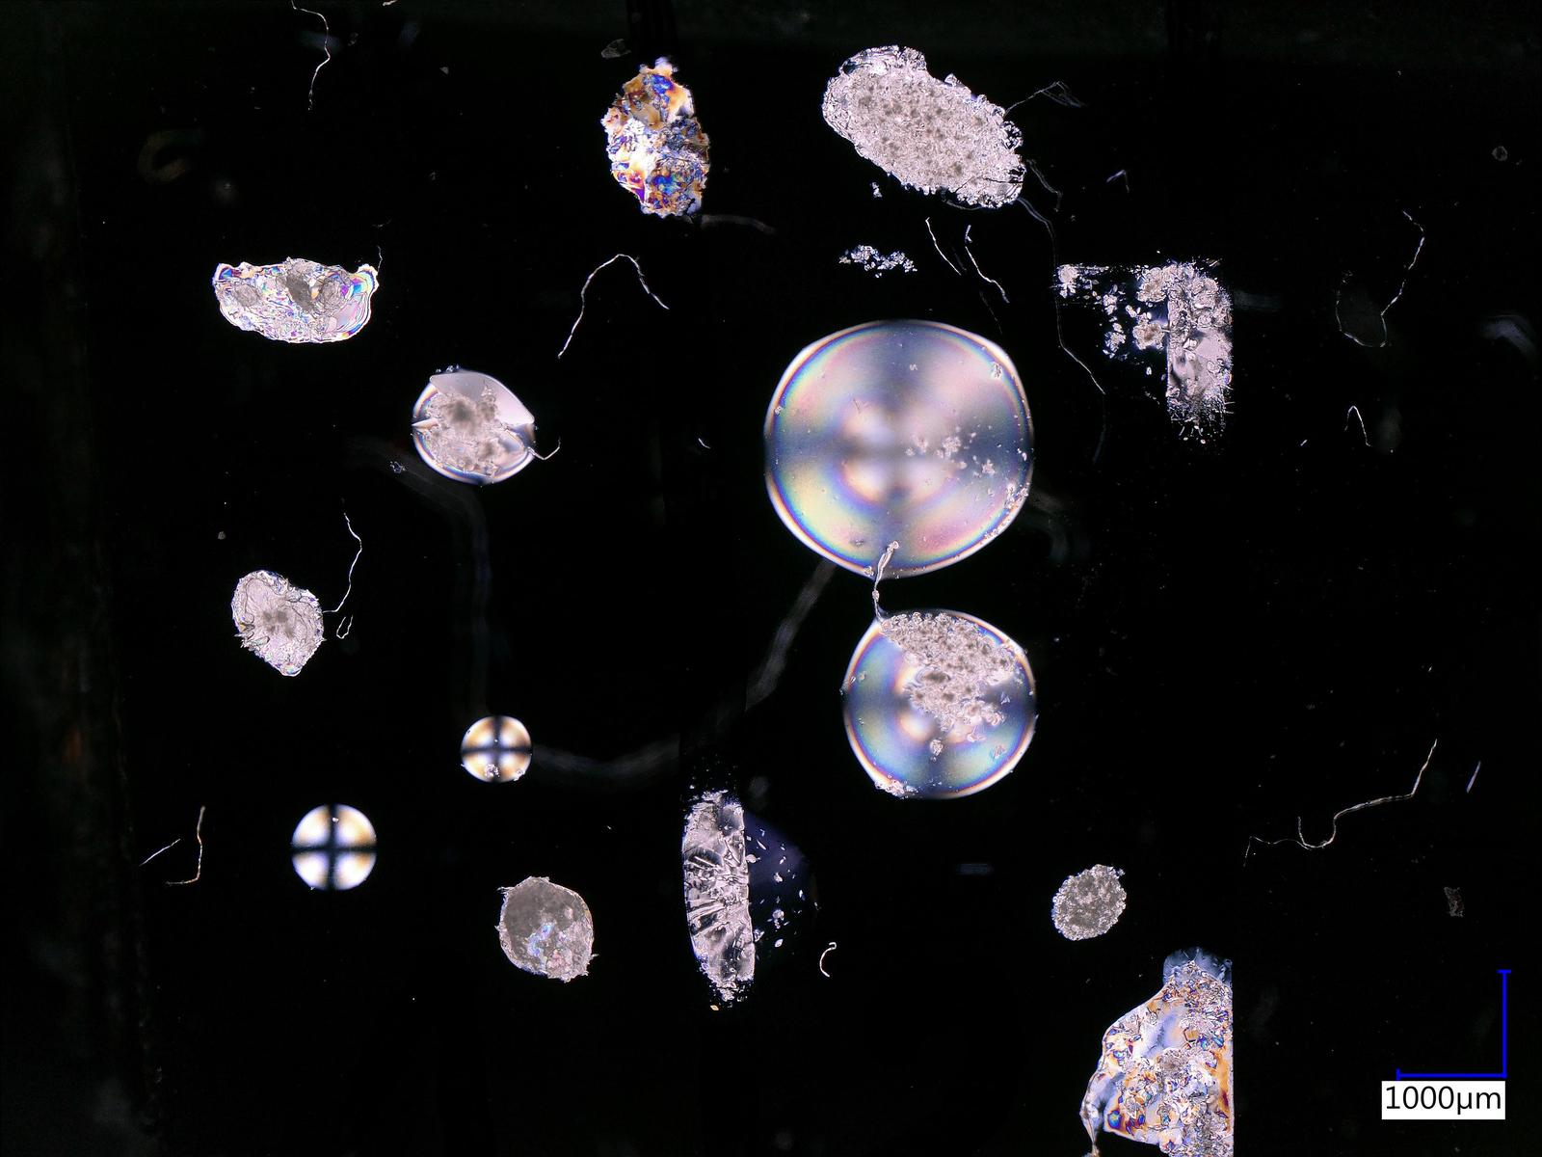 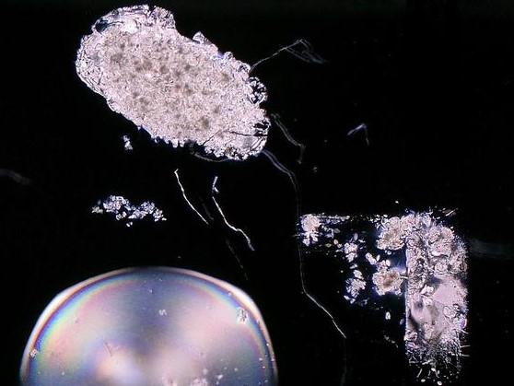  
*Liquid crystal drops on PDMS substrate - day 8.   
On the right, a magnification of an exemplary area of interest.*

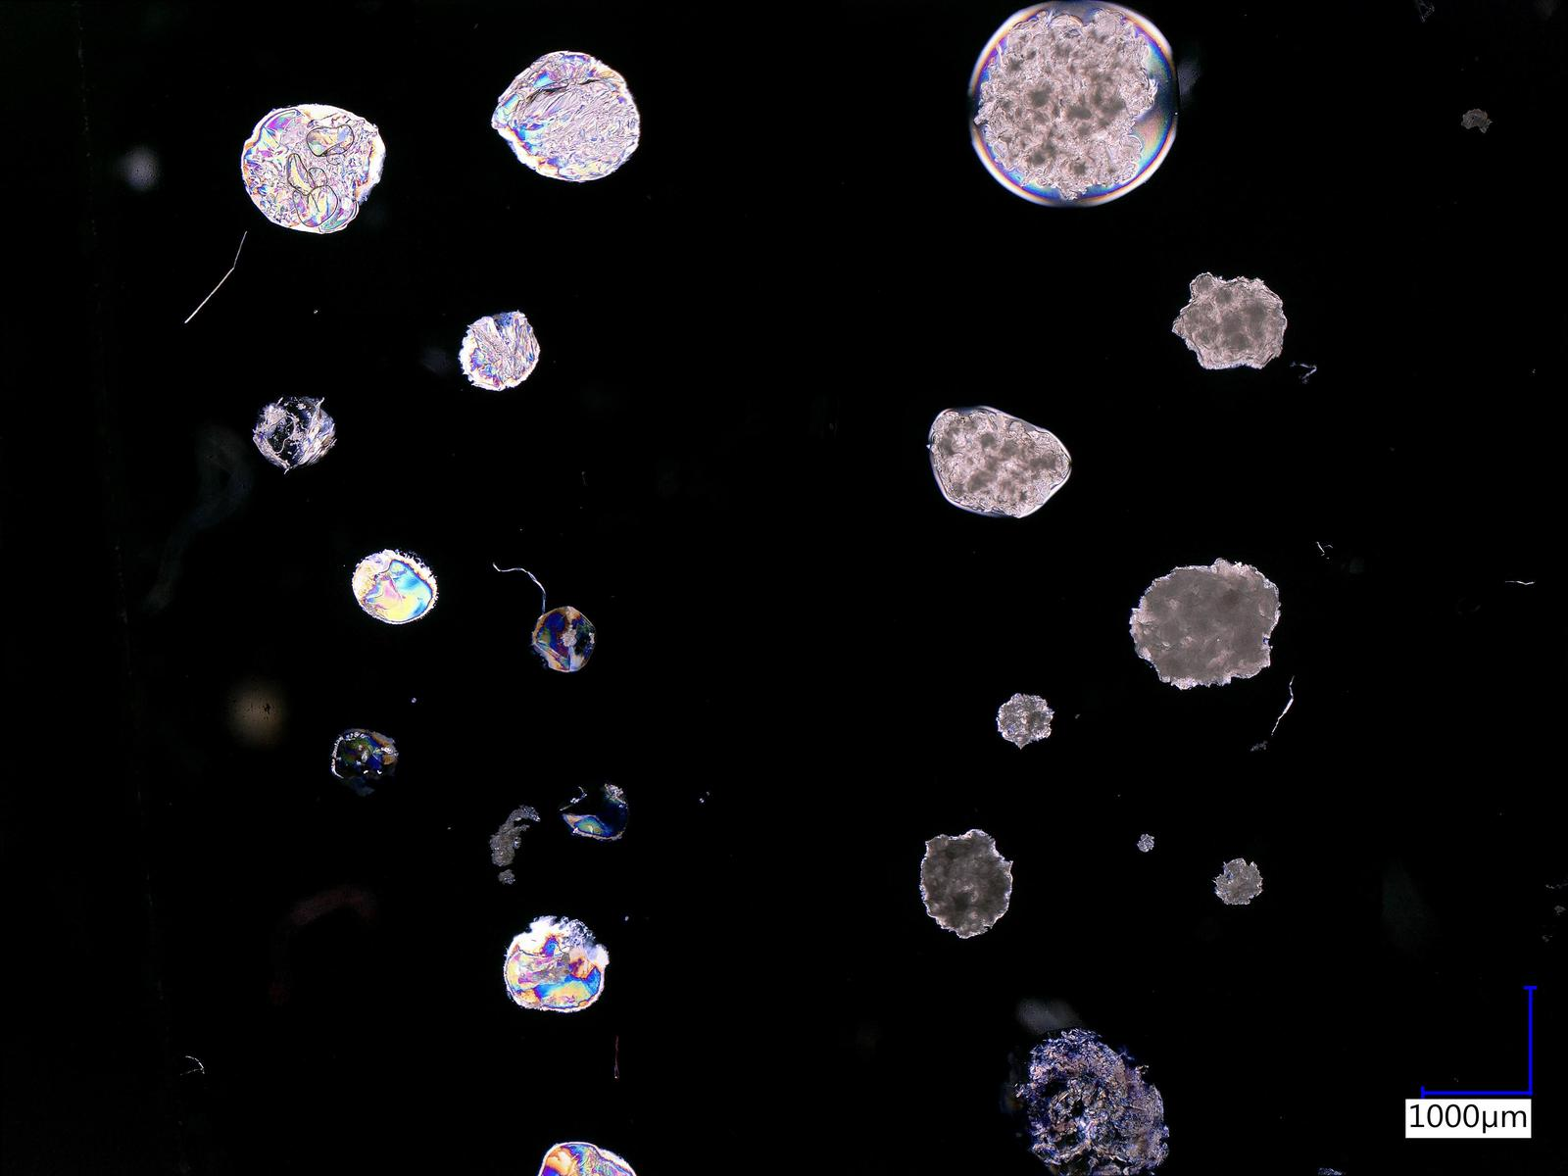 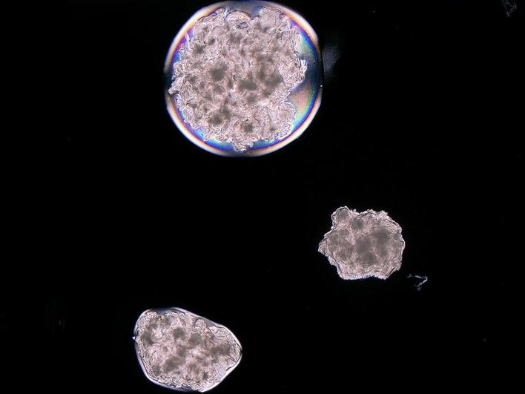  
*Liquid crystal drops on PDMS substrate - day 14.   
On the right, a magnification of an exemplary area of interest.*

1. Tools and models used

During the project, various tools were used to perform the training of a neural network adapted to the recognition of objects. Going from the beginning - after selecting the appropriate photos, a simple script in Python (version 3.7) was used, which changed the resolution to the chosen one. In this case, a resolution of 1600x1200 pixels was chosen to keep details. The next step was to mark the appropriate fragments of the photos with the LabelImg tool, which is a graphical image annotation tool. Annotations are saved as XML files in PASCAL VOC format and then combined into one CSV file using a Python script.

1. Wyniki + zdjęcia

Model 8k steps

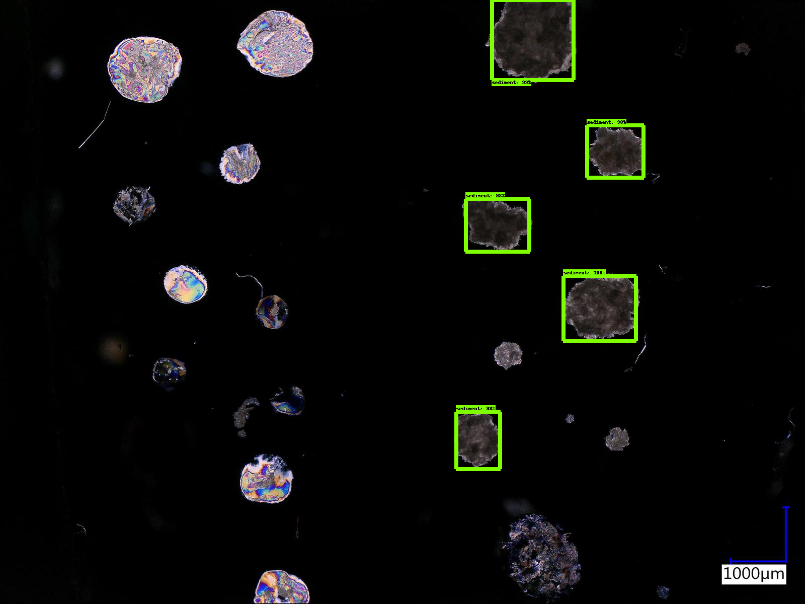

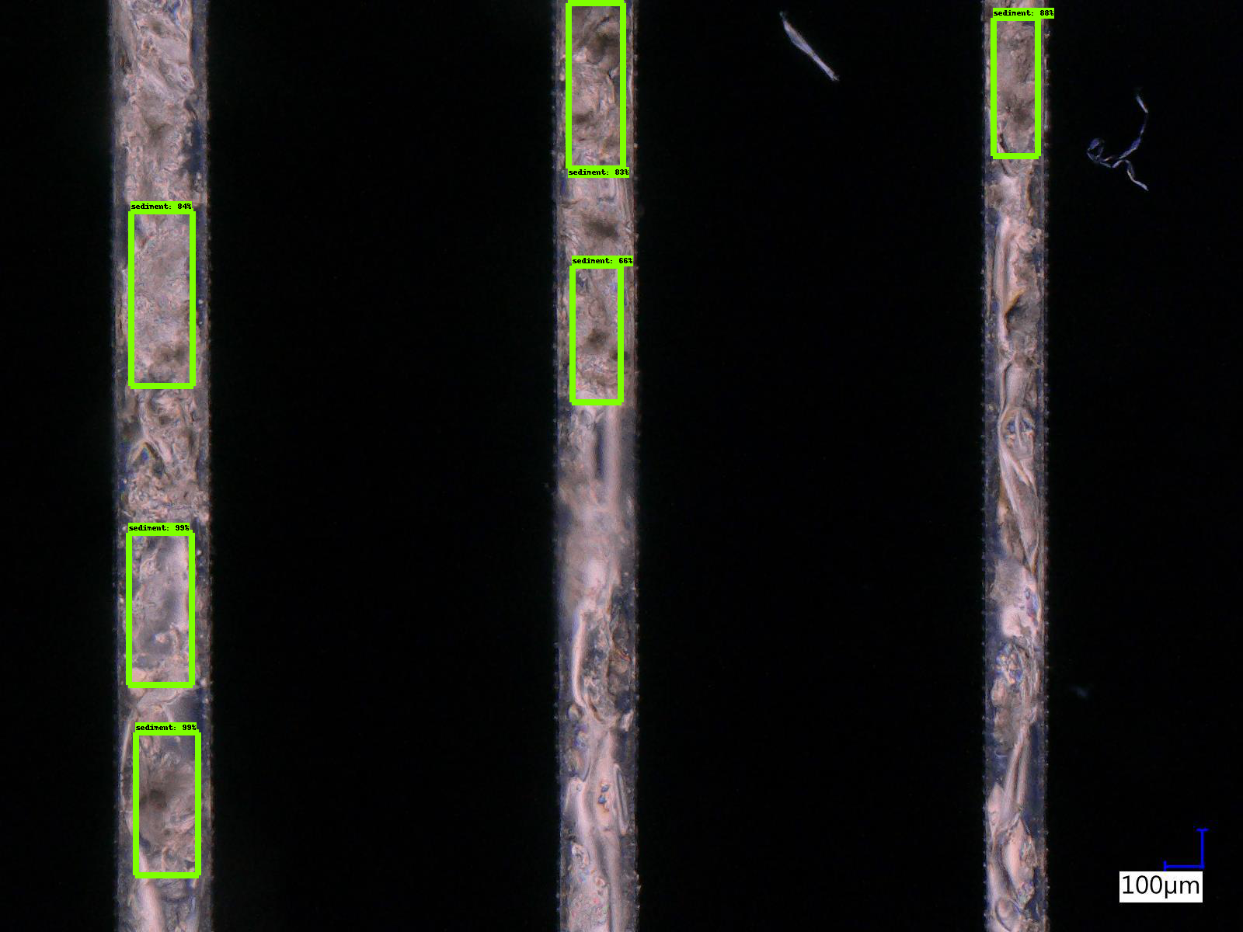

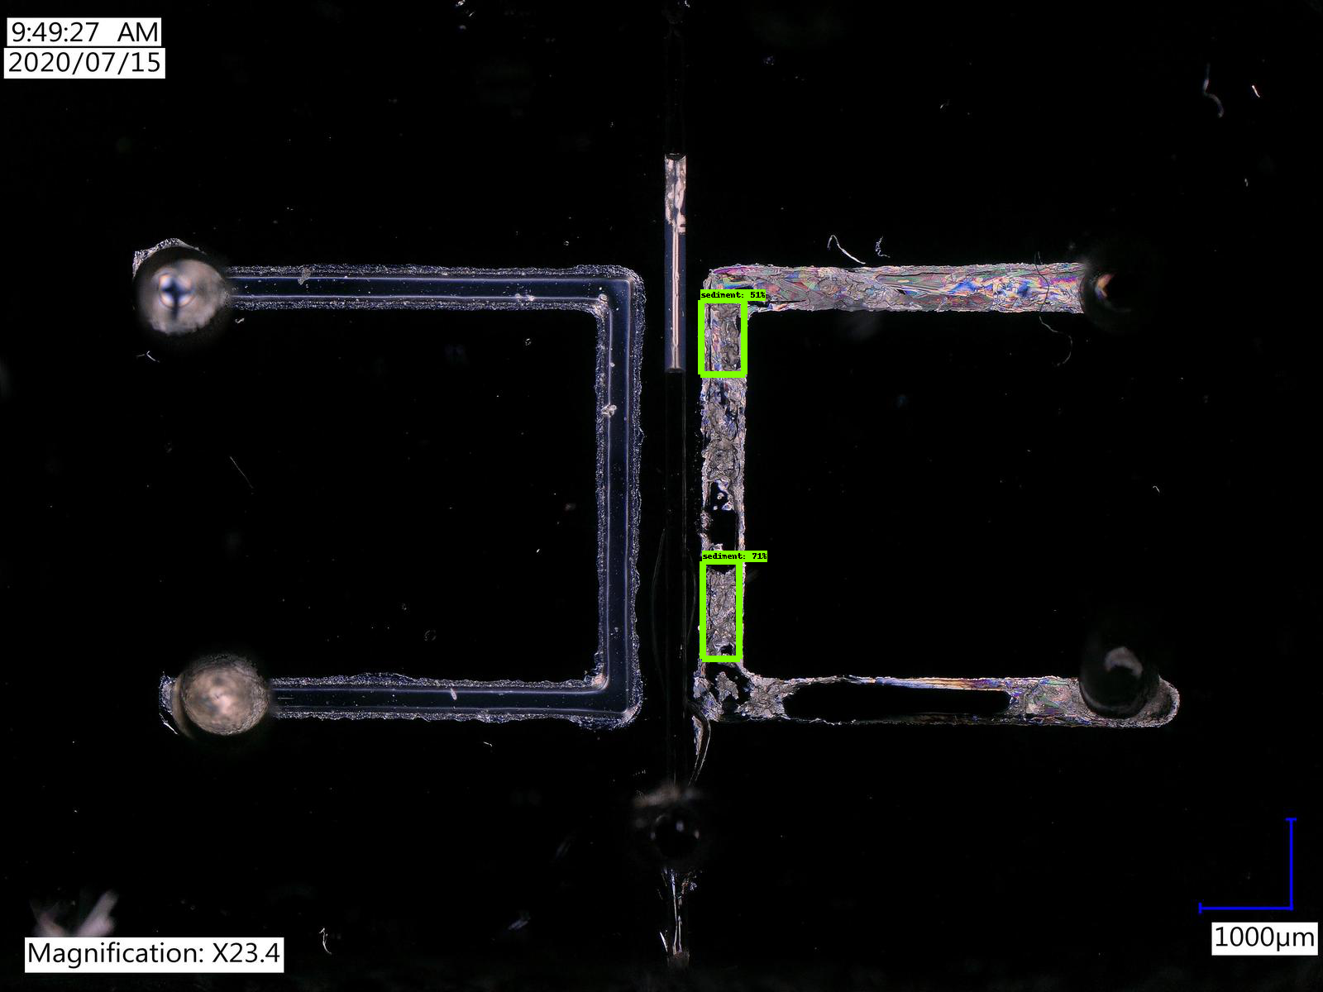

Model 3k steps

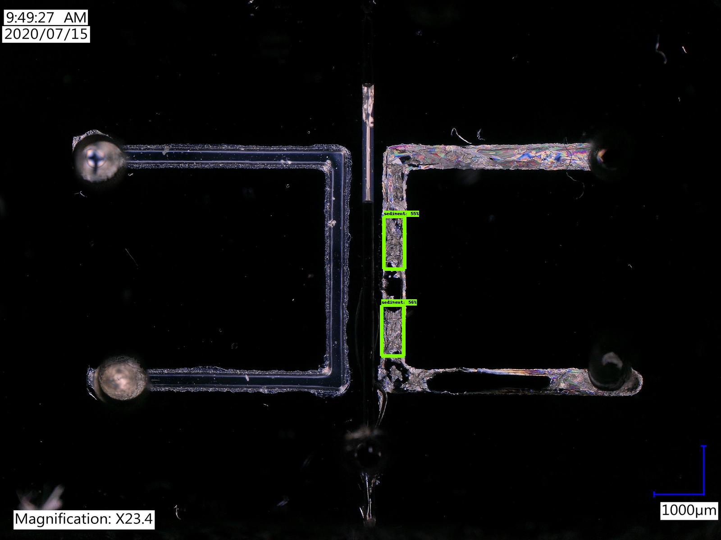

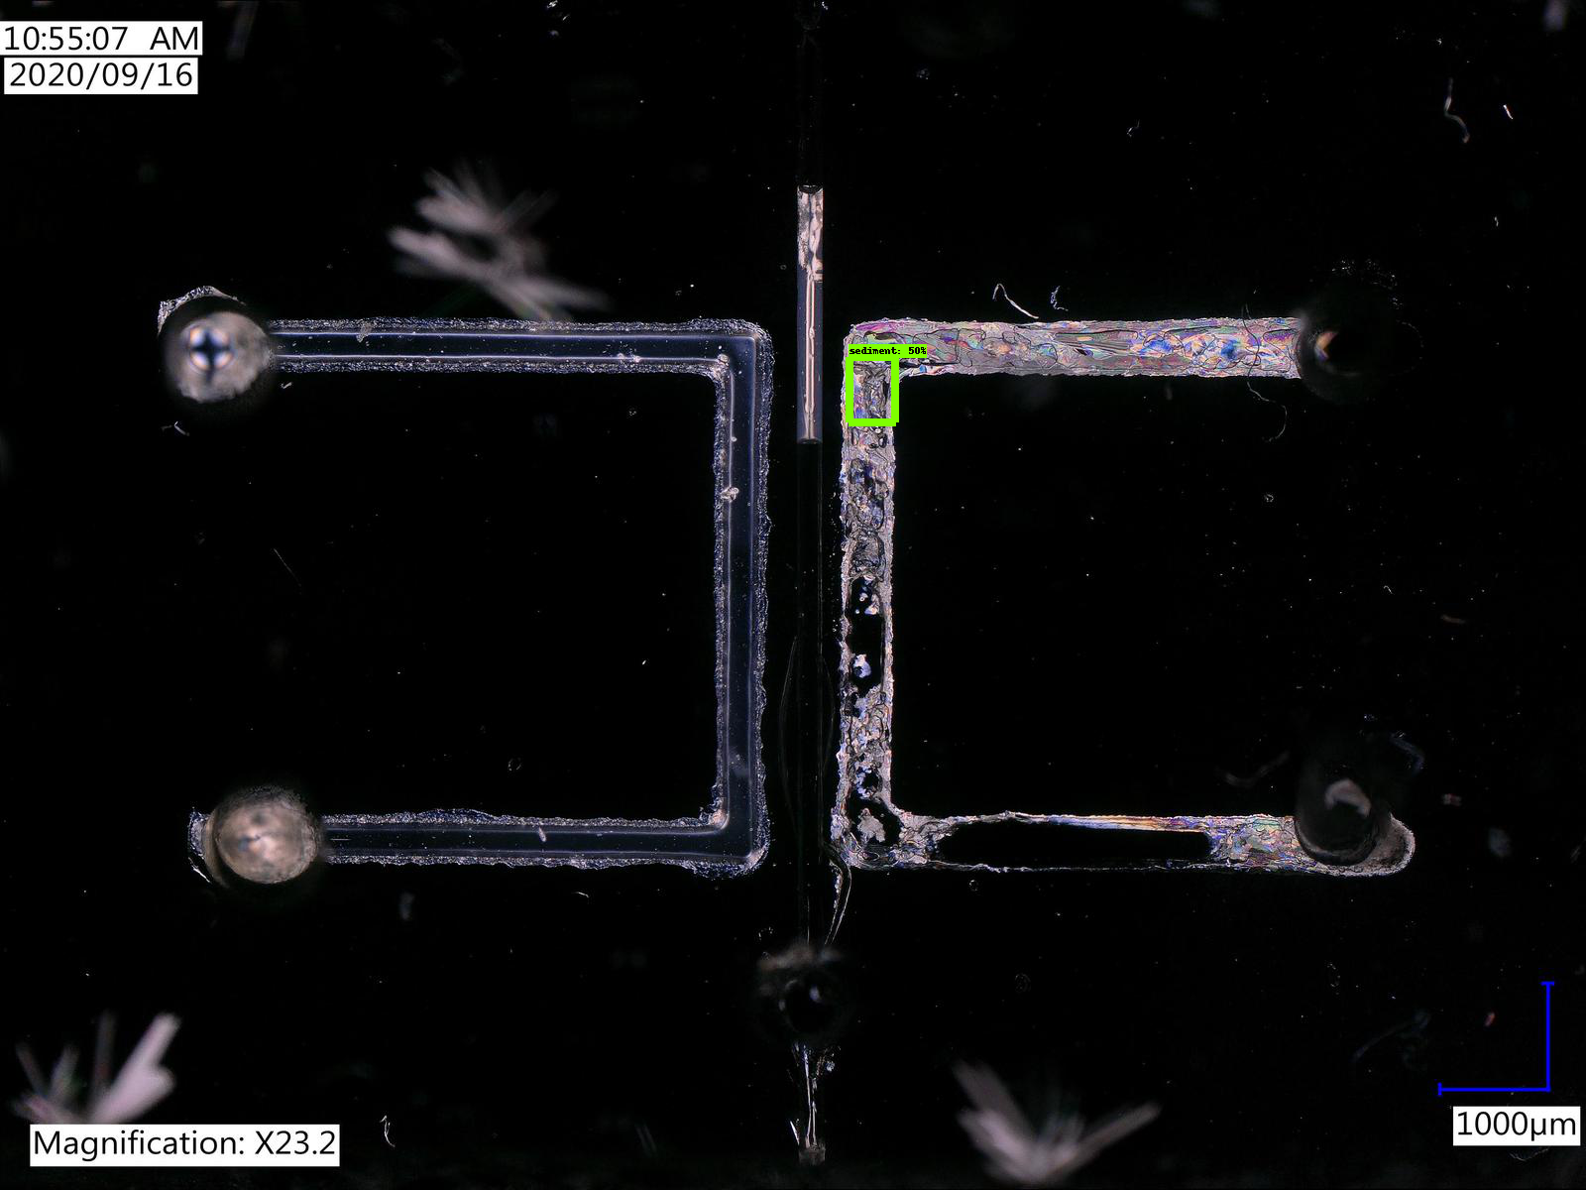

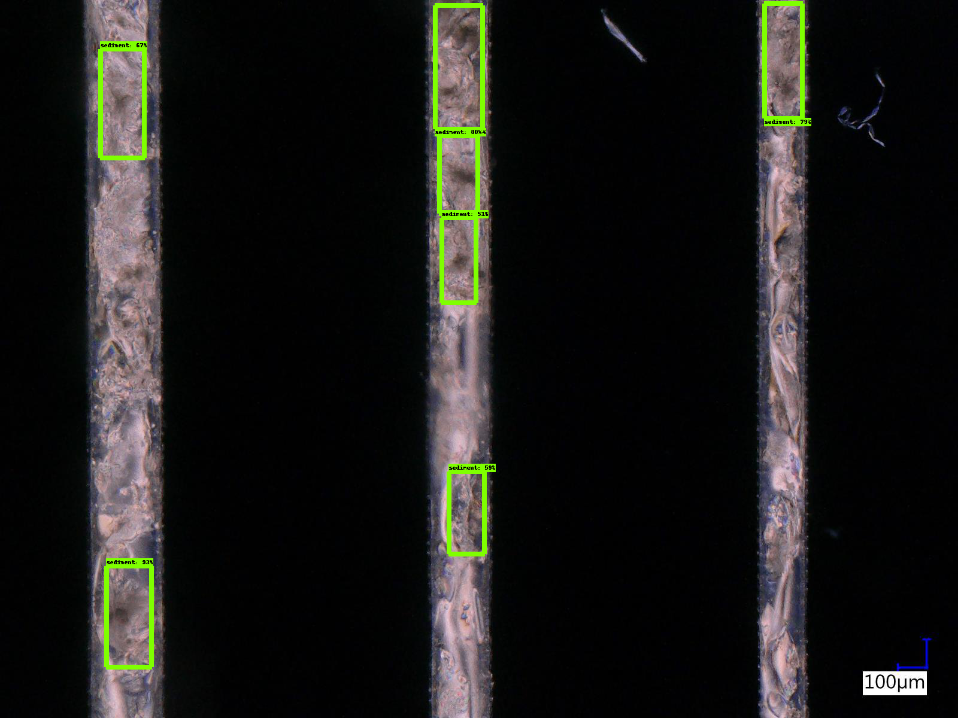

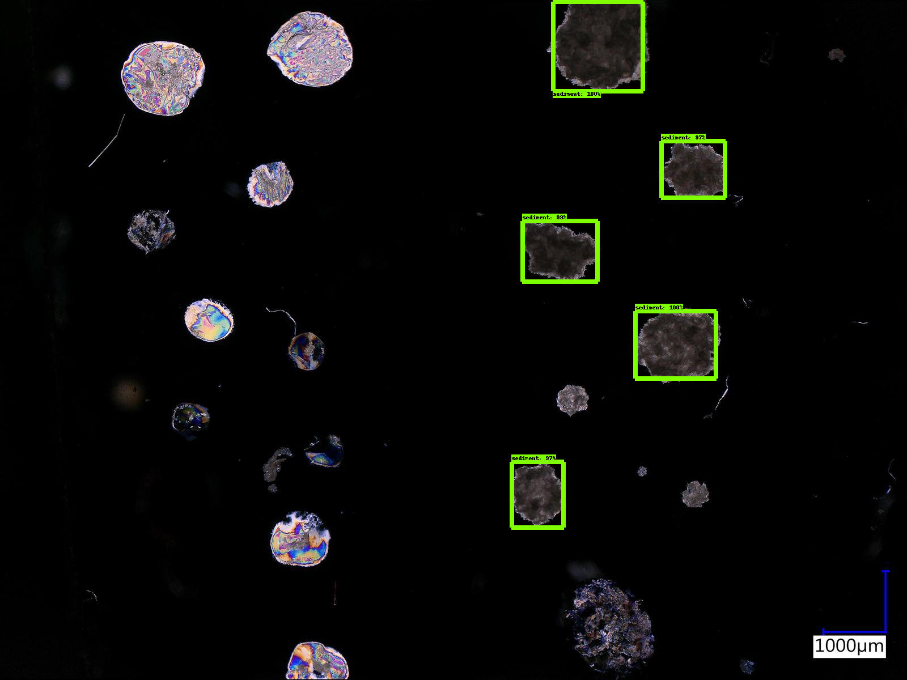

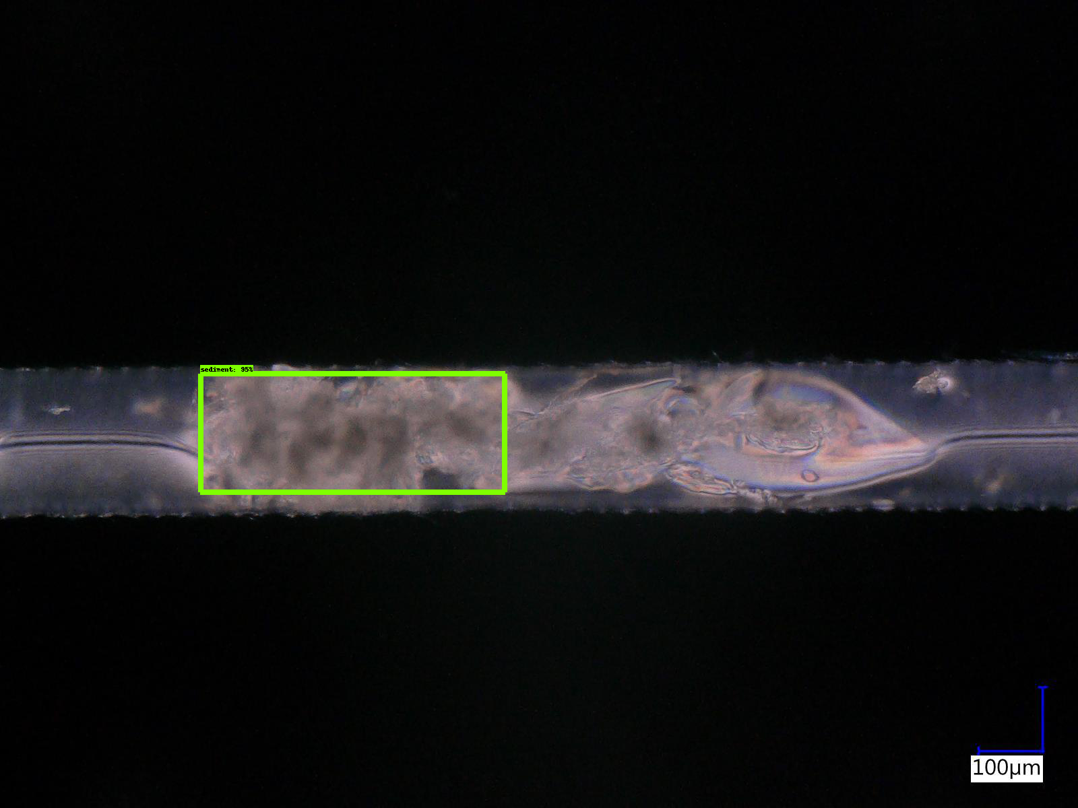

1. Kod